MEDIA REPORT

ECO-SAFE BIKE ROUTE 17/9/2021

The event was disseminated in 3 online media, 1 social media posts, X articles in newspapers…etc, after the event.

# BEFORE THE EVENT

…….

# AFTER THE EVENT

# WEBSITES

## Municipality of Platanias website

<https://www.platanias.gr/oloklirothike-epitychia-oikologiki-amp-asfalis-podilatiki-diadromi-metakinoymaste-mesa-filika-sto-perivallon-menoyme-ygieis-ti-symmetochi-3-dimotikon-scholeion-toy-dimoy-platania/>

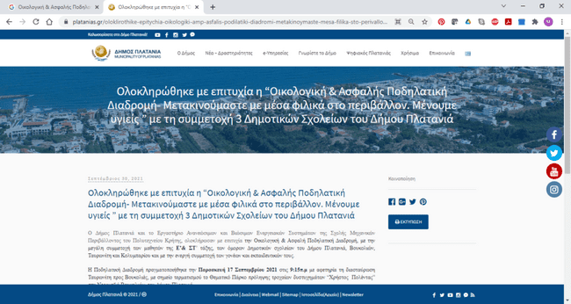

**2 ZARPA NEWS**

[**https://www.zarpanews.gr/chania-gemisan-podilata-oi-dromoi-toy-platania-me-megali-epitychia-i-symmetochi-ton-mathiton-photos/**](https://www.zarpanews.gr/chania-gemisan-podilata-oi-dromoi-toy-platania-me-megali-epitychia-i-symmetochi-ton-mathiton-photos/)

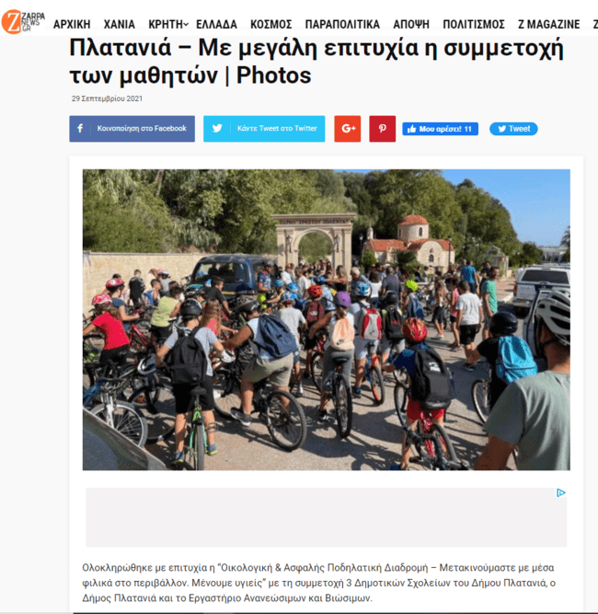

**3 HANIA NEWS**

[**https://hania.news/2021/09/29/%ce%94%ce%ae%ce%bc%ce%bf%cf%82-%ce%a0%ce%bb%ce%b1%cf%84%ce%b1%ce%bd%ce%b9%ce%ac-140-%ce%bc%ce%b1%ce%b8%ce%b7%cf%84%ce%ad%cf%82-%cf%83%cf%84%ce%b7%ce%bd-%ce%9f%ce%b9%ce%ba%ce%bf%ce%bb%ce%bf/**](https://hania.news/2021/09/29/%ce%94%ce%ae%ce%bc%ce%bf%cf%82-%ce%a0%ce%bb%ce%b1%cf%84%ce%b1%ce%bd%ce%b9%ce%ac-140-%ce%bc%ce%b1%ce%b8%ce%b7%cf%84%ce%ad%cf%82-%cf%83%cf%84%ce%b7%ce%bd-%ce%9f%ce%b9%ce%ba%ce%bf%ce%bb%ce%bf/)

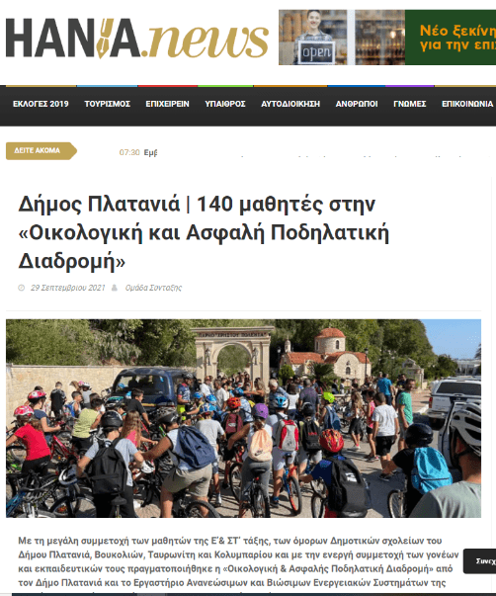

# SOCIAL MEDIA

## Municipality of Platanias FB page

<https://www.facebook.com/MunicipalityOfPlatanias/posts/4421869847905741>

22 likes, 2 shares, 2 comments

